**2. Our Service Scopes 我們提供的服務**

|  |  |
| --- | --- |
| 1. B2B (Business-to-Business) 2. B2C (Business-to-Consumer) 3. Regional Express 4. Logistics Solutions | 1. B2B (企業對企業) 2. B2C (企業對消費者) 3. 區域性跨境快遞 4. 物流配送解决方案 |

|  |
| --- |
| B2B  business-to-business  企業對企業 |

**Kerry Express is serving thousands of corporate customers who deliver parcels to offices and business locations.**

We understand that no two companies are the same. Therefore, in the B2B sector, we dedicate our Customer Relationship Management (CRM) Team to work closely with every customer to maintain the highest level of services.

**嘉里快遞為過千上萬小企業客戶服務，包括私人客戶與商業客戶之間遞送包裹。**

我們了解，每間機構或企業不同。因此，在B2B(企業對企業)領域，我們致力於提供一站式客戶關係管理解決方案(CRM)，我們團隊與每一位客戶緊密合作，以保持企業業務水平。

Standard Services Specification 標準服務規範

|  |  |  |  |  |
| --- | --- | --- | --- | --- |
| Service provided | Cut-off Time | Shipment Pick-up | Shipment Delivery | Delivery Report Submission |
| 提供服務 | 截件時段 | 上門收貨 | 託運派送 | 派送報告 |
| Monday  to  Friday  星期一  至  星期五 | before 10:30 | Same day  09:00 – 12:30  當日 | Same day  14:00 – 18:00  當日 | Same Day  當日 |
| 10:30 – 3:30 | Same day  14:00 – 18:00  當日 | Next working day  09:00 – 12:30  下一個工作天 | Next Wave  翌日 |
| after 3:30 | Next working day  09:00 – 12:30  下一個工作天 | Next working day  14:00 – 18:00  下一個工作天 |
| Saturday  星期六 | before 10:30 | Same day  09:00 – 12:30  當日 | Next working day  09:00 – 12:30  下一個工作天 |

Services for Individuals and SME 針對個人及中小企業服務

|  |  |
| --- | --- |
| Same day Delivery  Service Points  Self-Pick Service  Mobile Booking  Payment Collection  3-Hour Urgent Express  Time and Day Definite Services | 當天發貨  服務點  自提服務  手機預訂  代收貨款  3小時特快派遞  定時及定日快遞服務 |

|  |
| --- |
| B2C  Business to consumer  企業對消費者 |

**Kerry Express is serving nearly all e-commerce platforms in Hong Kong**

Hong Kong’s B2C sector is experiencing robust growth.

E-Commerce and home-shopping companies need a strong partner to deliver their products to individual shoppers at their offices or homes.

Moreover, we know that user’s experience is important. Therefore, **Kerry Express** is investing heavily on people, technology and equipment to further improve the experience and convenience of the shoppers in tracking and receiving parcels from us.

Kerry Express can of course also be the payment-on-delivery operator. We help B2C customers to collect cash, credit card at the doorstep from the shoppers.

**嘉里快遞服務遍及幾乎所有電子商務平台**

香港企業對企業(B2B)的電子商務正急速增長，對於電子商務企業需要一個強大的合作夥伴，將商品派送到消費者辦公室或府上，服務覆蓋範圍遍及全香港。

此外，我們了解消費者購買體驗是非常重要的。爲此**嘉里快遞**不惜投入巨大人力資源，技術和設備，進一步為消費者提升便利及輕鬆的購物體驗。

**嘉里快遞**當然也可以代收貨款營運商。我們幫助客戶(B2B)將商品送至消費者府上代收現金或信用卡。

E-commerce one-stop solution 一站式電子商務解決方案

|  |  |
| --- | --- |
| Home Delivery  Pre-delivery notification  Self-Pickup Solution  COD  Return Management  API Integration  Track and Trace | 住宅送貨  送貨前通知  自提解決方案  代收貨款  退貨管理  API 應用程式介面  運件追蹤 |

Timeline 時間軸

Day 0 Day 0 Day 1 Day 1 Day 2

|  |  |  |  |  |
| --- | --- | --- | --- | --- |
| Ordering | Shipment Pick-up | Shipment Delivery | Real-time Track and Trace | POD (Electronic Proof of Delivery) |
| 訂單 | 上門收貨 | 託運派送 | 實時運件追蹤 | 電子簽收交付証明 |

|  |
| --- |
| Regional Express  區域性快遞 |

Solutions

Kerry Express provides one-stop express services. Regardless of single or multi-modal shipment, customs clearance and door-to-door distribution. Furthermore, we can finish the customs clearance and documentation delivery for you.

Throughout the delivery process, you can consult about the know-how in respect of supervisory regulations on import and export goods. We will strictly comply with all customs regulations to ensure successful goods delivery. You will feel at ease as you will be well informed of the delivery.

You just make a phone call, and we will provide you with on-demand point-to-point delivery service.

嘉里快遞提供一站式國際快遞專線，無論是單一或是多聯式貨運、清關至戶到戶派送等服務，我們亦為您辦理一切清關及文件運送等工作，確保運送完整。

在整個運送過程中，你更可徵詢有關進出口貨物監管規例的專業知識，而我們會嚴謹遵守所有海關條例，

無論在運送途中或已送抵，你都可對整個運送過程瞭如指掌，倍感安心。

一個電話，隨傳隨到，點對點送件服務。

Areas Served服務地區

Mainland China中國內地

Thailand泰國

Malaysia馬來西亞

Taiwan台灣

Laos老撾

Cambodia柬埔寨

Macau澳門

Korean韓國

Singapore新加坡

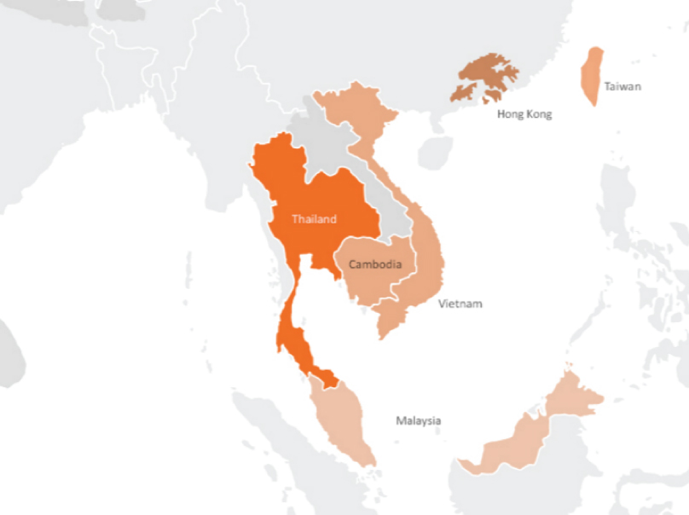 [**http://th.kerryexpress.com/en/about/**](http://th.kerryexpress.com/en/about/)

|  |
| --- |
| Logistics Solutions  物流配送解决方案 |

Solutions解决方案

|  |  |
| --- | --- |
| Oversea Consolidation  HKG Terminal pickup  Inventory Management  Customs Clearance (HKG/CHINA)  Home Delivery (HKG/CHINA) | 海外貨物集運  香港貨櫃碼頭收貨  庫存管理  海關清關(香港/中國)  住宅送貨(香港/中國) |

Inventory Management 庫存管理

|  |  |
| --- | --- |
| Strong network base of Kerry Logistics Warehousing  Value Added Services (Light assembly, Customized labeling, Repacking, Co-packing)  E-Commerce Fulfillment  Self-proprietary WMS (Warehouse Management System) | 嘉里物流擁有強大倉儲及配送基礎設施  增值服務 (簡單貨物組裝,定製標籤, 重新包裝, 共同包裝)  電子商務配送  獨創倉庫管理系統 |